# MOTIVATION FORM FOR EU-CORE (MANDATORY)

**General Instructions (please read carefully)**

To demonstrate your motivation and background for EU-CORE, please fill out the mandatory motivation form.

There are **2 parts** that must be completed. **Failing to use this mandatory form will result in receiving a grade of 0 on the motivation criterion.**

Use font size 11 or 12.

**PART I – About you and your motivations for the programme**

**Instructions:**

This part helps us understand who you are, both as a person and potentially as a future EU-CORE student.

**There is no need to address anyone** with an introductory phrase such as “To whom it may concern” or “Dear…”

Simply answer each question individually, as you would do in a regular form. Don’t use connecting words between your answers.

1. **Personal introduction (400 characters max, spaces not included).**

Write your answer here.

1. **Briefly state why you want to apply for EU-CORE and why you chose a specific master’s programme on renewable energy system (400 characters max, spaces not included).**

Write your answer here.

1. **Describe your strongest qualifications, past experiences and personal qualities that will help you to succeed in EU-CORE. Provide verifiable achievements with your claims such as prizes, recognition or ranking in specific competition (800 characters max, spaces not included).**

Write your answer here.

1. **Elaborate on your intended professional development path after getting your EU-CORE master’s degree (400 characters max, spaces not included).**

Write your answer here.

**PART II – About your background**

**Instructions:**

This section complements your transcripts to help us understand your academic background in relation to the EU-CORE programme.

Complete tables 1 and 2 as instructed

**Table 1 – Your prior degree**

|  |  |
| --- | --- |
| **Undergraduate degree title (if you have already obtained a master, include it)** | Write your answer here. |
| **Specify any minor/major or specialization** | Write your answer here. |

**Table 2 – Connections between your curriculum and the EU-CORE programme**

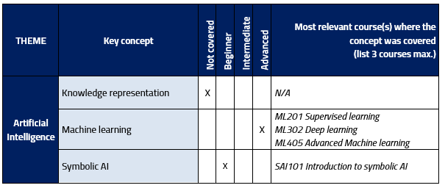Below is an example on how to fill out the table (the matrix to fill out is on the next 2 pages, in blue):

|  |  |  |  |  |  |  |
| --- | --- | --- | --- | --- | --- | --- |
| **THEME** | **Key knowledge** | **Not covered** | **Beginner** | **Intermediate** | **Advanced** | **Most relevant course(s) where the knowledge was covered  (list 3 courses max.)** |
| **Electrical Engineering** | Electric circuits |  |  |  |  | Write your answer here. |
| Electric machines |  |  |  |  | Write your answer here. |
| Energy conversions and storages |  |  |  |  | Write your answer here. |
| **Mechanical Engineering** | Fluids and solid mechanics |  |  |  |  | Write your answer here. |  |  |  |
| Heat and mass transfer |  |  |  |  | Write your answer here. |
| Mechatronics |  |  |  |  | Write your answer here. |
| **Control  Engineering** | Signals and systems |  |  |  |  | Write your answer here. |
| Linear control |  |  |  |  | Write your answer here. |
| Nonlinear control |  |  |  |  | Write your answer here. |
| **Process Engineering** | Optimization |  |  |  |  | Write your answer here. |
| Modeling and simulation |  |  |  |  | Write your answer here. |
| Process control |  |  |  |  | Write your answer here. |

|  |  |  |  |  |  |  |
| --- | --- | --- | --- | --- | --- | --- |
| **THEME** | **Key knowledge** | **Not covered** | **Beginner** | **Intermediate** | **Advanced** | **Most relevant course(s) where the knowledge was covered  (list 3 courses max.)** |
| **Computer**  **Engineering** | Computer architecture |  |  |  |  | Write your answer here. |
| Python/C/C++ |  |  |  |  | Write your answer here. |
| Scientific/numerical computing softwares (e.g. Matlab, Mathematica, Julia, Octave or similar) |  |  |  |  | Write your answer here. |